Computer Shop System

Version 1.0

Revision History

|  |  |  |  |
| --- | --- | --- | --- |
| **Date** | **Version** | **Description** | **Author** |
| 12/12/2019 | 1.0 | details | Tran Van Dat |
|  |  |  |  |
|  |  |  |  |
|  |  |  |  |

Table of Contents

1. Introduction 2

1.1 Purpose 2

1.2 Scope 2

1.3 Definitions, Acronyms, and Abbreviations 2

1.4 References 2

1.5 Overview 2

2. Flow of Events—Design 2

3. Derived Requirements 2

# Introduction

## Purpose

This document describes how the Log-in Use case is realized within the design model

## Scope

This document applies to the Computer Shop System system which will be developed by our group

## Definitions, Acronyms, and Abbreviations

None

## References

None

## Overview

In the following section, flow of events-design is a textual description of how the use case is realized in terms of collaborating objects. Its main purpose is to summarize the diagrams connected to the use case and to explain how they are related. The last part is derived requirements. A textual description that collects all requirements, such as nonfunctional requirements, on the use-case realizations not considered in the design model, but that need to be taken care of during implementation.

# Flow of Events—Design

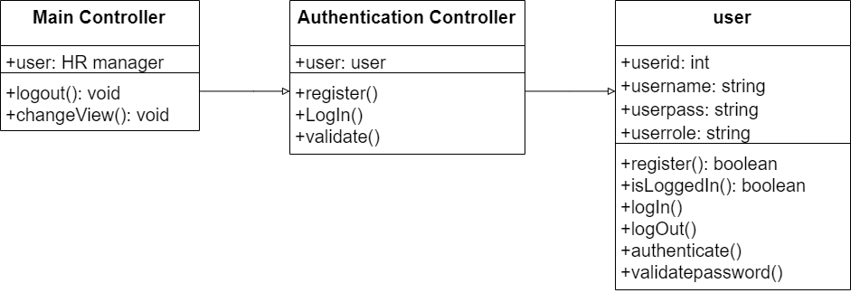

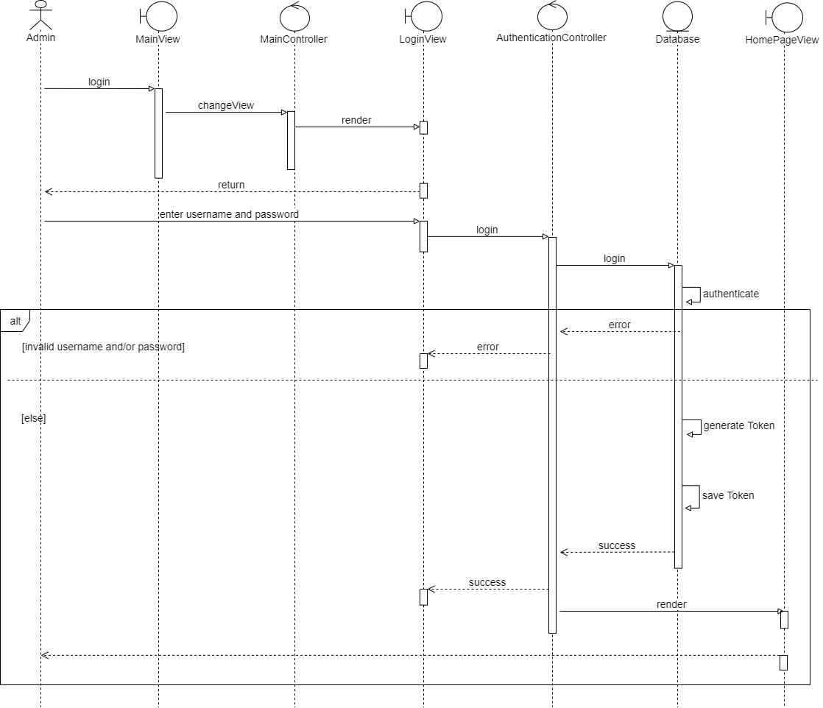

# Derived Requirements

None